RURAL KOTZEBUE POLICE

TELEPHONE / FIELD INTERVIEW TRANSCRIPT
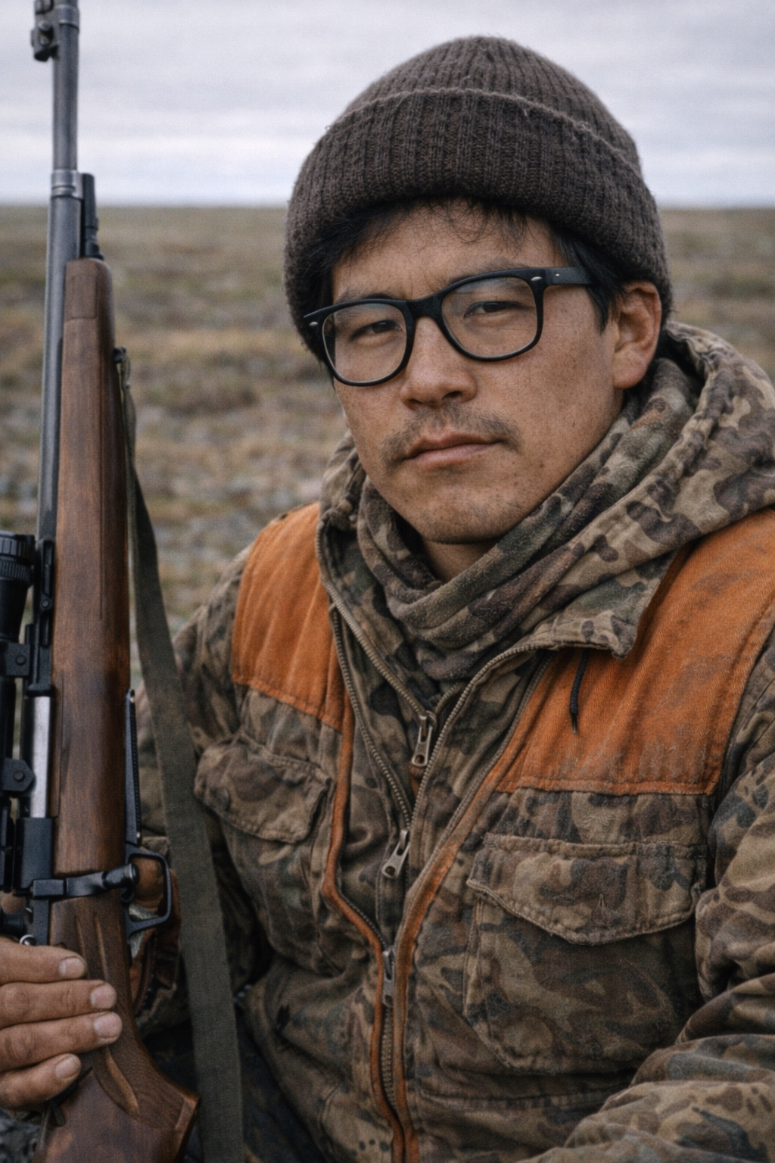

Case Number: RKP-KO-84-0616-447
Date: June 16, 1984
Time: 11:47 AM
Officer: Sgt. Elaine Mercer
Subject: George Suli
Context: Missing Person – Dr. Barry Raven (Search Coordination)BEGIN TRANSCRIPT
Sgt. Mercer: Rural Kotzebue Police. Sergeant Mercer speaking.
George Suli: This is George Suli. I understand you’re calling about Dr. Raven.
Sgt. Mercer: Yes. We’re initiating coordination for a search effort. We need any information you have regarding his intended location or field plans.
George Suli: I’ve already looked into it on my end. I checked the notes and spoke briefly with people at the clinic. There’s nothing concrete on where he was headed.
Sgt. Mercer: He was last confirmed seen June 13th.
George Suli: Right. And that’s the problem. No one seems to have a destination. No scheduled field site, no travel plan logged that I can find.
Sgt. Mercer: Was he conducting research at the time of disappearance?
George Suli: Yes, but not anything formally scheduled. He and Council have been working loosely on coastal field trips, nothing structured.
Sgt. Mercer: You are referring to Dr. Henry Council?
George Suli: Correct.
Sgt. Mercer: Do you know his current location?
George Suli: Not exactly. He’s supposed to arrive in Kotzebue on the eighteenth.
Sgt. Mercer: Two days from now.
George Suli: Yes. He may already be traveling, or still en route. Communication is unreliable this time of year.
Sgt. Mercer: Do you believe Dr. Council may know Dr. Raven’s intended movements?
George Suli: If anyone does, it would be him. They coordinated field work, even if it wasn’t always formally documented.
Sgt. Mercer: We will attempt contact upon his arrival.
George Suli: I’ll try as well. If I can reach him sooner, I will.
Sgt. Mercer: What about search coordination?
George Suli: I’ll assemble a small field team. Local knowledge is going to matter more than anything else out there.
Sgt. Mercer: Conditions?
George Suli: Variable. Coastal wind patterns have shifted. If Raven went north or south toward the bluffs, visibility drops fast. Weather and seas could change within hours.
Sgt. Mercer: Any indication he planned to travel in either direction?
George Suli: None that I’ve seen.
Sgt. Mercer: So at this point, you have no confirmed destination.
George Suli: No. Just gaps.
Sgt. Mercer: Understood. We will coordinate with your team for a joint search effort.
George Suli: Good. The sooner we get boats out there, the better.
Sgt. Mercer: Final questions—does Dr. Raven have any reason to deviate from routine travel without informing anyone?
George Suli: Not normally. For all I know he could be out camping for fun and didn’t tell anyone.
Sgt. Mercer: Does Dr. Raven travel to remote sites alone?
George Suli: No. That’s what makes this unusual.
END TRANSCRIPT

Officer Notes (Sgt. Mercer):
Subject cooperative and technically informed. Confirms absence of documented field destination for Dr. Raven. Indicates reliance on Dr. Henry Council for research coordination; Council not currently reachable until expected arrival on June 18th. Search area remains undefined due to lack of known itinerary. Investigation escalated to coordinated field response planning.

