RURAL KOTZEBUE POLICE

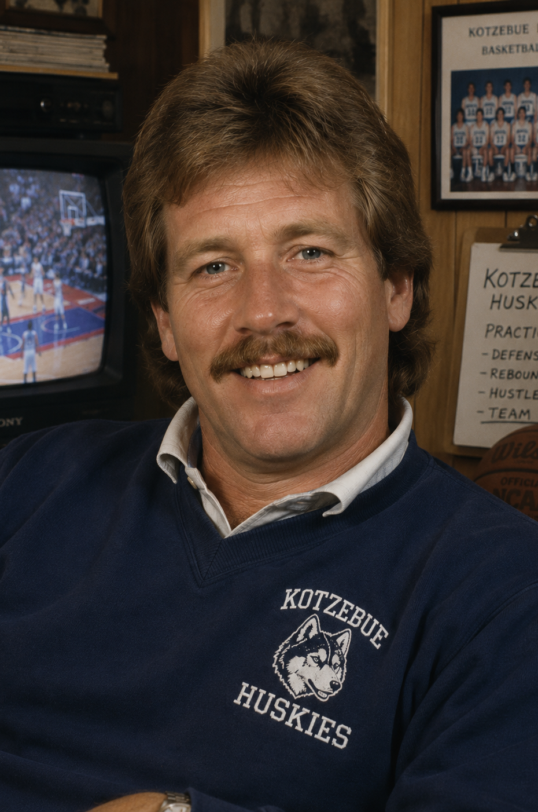
AUDIO CALL TRANSCRIPT (BILLY DONNE)

Case Number: AST-KO-84-0616-447
Date: June 16, 1984
Time: 14:38
Officer: Sgt. Elaine Mercer
Caller: Billy Donne

Sgt. Mercer: Rural Kotzebue Police.
Billy Donne: Yeah, this is Billy Donne. I’m calling about Barry Raven.
Sgt. Mercer: Go ahead.
Billy Donne: I just found out Hazel went over to his house this morning.
Sgt. Mercer: She reported doing a welfare check this afternoon.
Billy Donne: No—I mean this morning. Before all this missing person stuff got serious.
Sgt. Mercer: Do you know why she was there?
Billy Donne: I don’t know why Hazel was over there. She knows I’ve told her she’s not supposed to be at Raven’s house.
Sgt. Mercer: Why is that?
Billy Donne: Because she just shouldn’t be. It complicates things.
Sgt. Mercer: Complicates what?
Billy Donne: Nothing. It just does.
Sgt. Mercer: We also need to address Dr. Raven’s status. You believe he is simply late?
Billy Donne: Yeah. He’s probably just running behind. Flights, weather—this is Kotzebue.
Sgt. Mercer: He hasn’t reported to work or contacted anyone since June 15th. His last sighting was on June 12th or 13th.
Billy Donne: That doesn’t automatically mean something happened.
Sgt. Mercer: Your wife Hazel disagrees and believes something is wrong.
Billy Donne: Hazel always thinks something is wrong.
Sgt. Mercer: Earlier you said she is “not supposed to be” at his residence. Explain that.
Billy Donne: She knows I don’t like it. That’s all I meant.
Sgt. Mercer: Why?
Billy Donne: It’s personal. And unnecessary.
Sgt. Mercer: Is there any reason Dr. Raven would avoid contact with her?
Billy Donne: No. I don’t think so.
Sgt. Mercer: So you have no concerns about his disappearance?
Billy Donne: I didn’t say that.
Sgt. Mercer: Then what is your assessment?
Billy Donne: Just… don’t turn this into something it’s not.
Sgt. Mercer: Understood. One final question—why exactly should Mrs. Donne avoid Dr. Raven’s residence?
Billy Donne: …No comment.

