RURAL KOTZEBUE POLICE – INTERVIEW TRANSCRIPT

NOAH KIVIGAQ
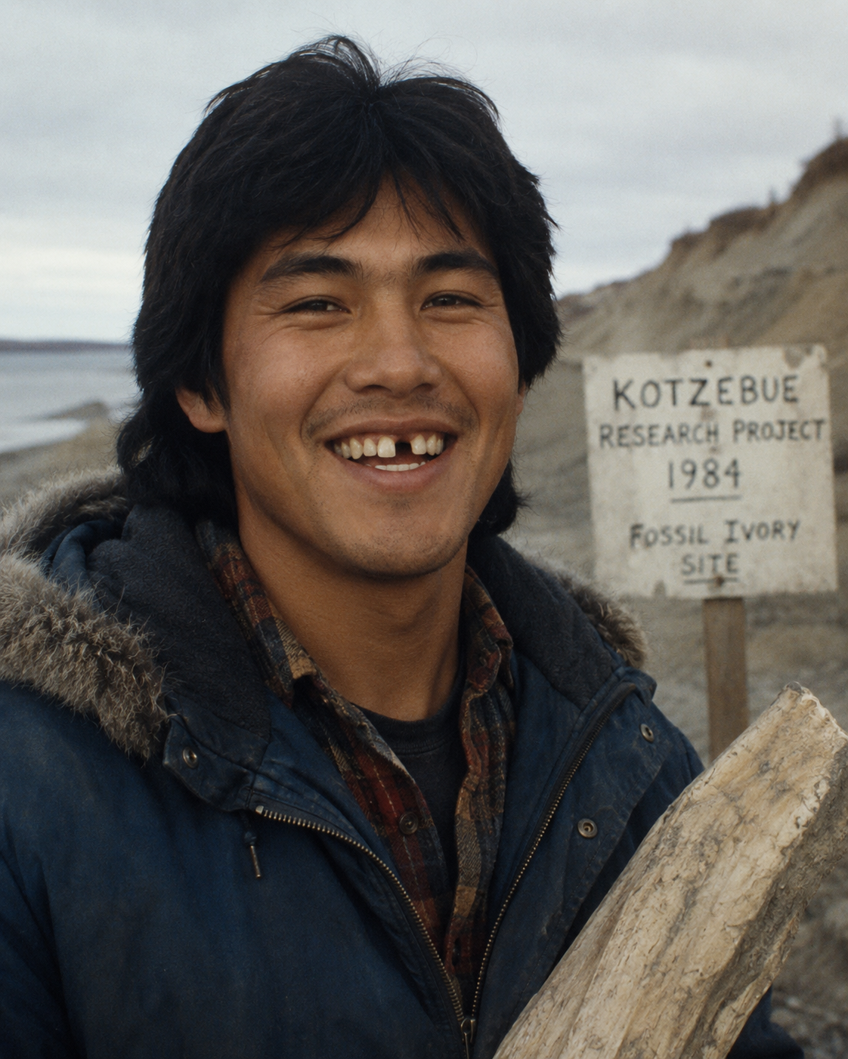
Case Number: RKP-NO-81-0913-118
Date: September 13, 1981
Officer: Sgt. Elaine Mercer
Subject: Noah Kivigaq
Charge Reference: Trespassing / Assault on Federal Property (Cape Krusenstern National Monument)

Sgt. Mercer: State your name for the record.
Kivigaq: Noah Kivigaq.
Sgt. Mercer: You were arrested at Cape Krusenstern in 1981 for trespassing on restricted federal land and assaulting an RKP officer during arrest.
Kivigaq: That again?
Sgt. Mercer: It’s relevant to your history with Dr. Raven’s field operations.
Kivigaq: No, it’s relevant because you fellas never let it go. Three years ago and you still drag it out every time I sit in one of these rooms.
Sgt. Mercer: National Park Service Ranger Kent Smith reported that you shoved Officer Daniels during arrest.
Kivigaq: Kent Smith wasn’t even the one grabbing me. Daniels was.
Sgt. Mercer: The report says you resisted arrest.
Kivigaq: The report says whatever you people want it to say. Daniels put hands on me first. I pushed him off me.
Sgt. Mercer: So you admit striking an officer?
Kivigaq: I admit I didn’t just stand there and let him throw me around.
Sgt. Mercer: You seem angry about it.
Kivigaq: Yeah, because you fellas are always trying to pin things on us Natives. Doesn’t matter what happens — somebody from Kotzebue ends up the problem.
Sgt. Mercer: Let’s stay focused on Dr. Raven. You worked for him?
Kivigaq: Worked with him. Sometimes for him.
Sgt. Mercer: Doing what?
Kivigaq: Survey work. Fossils. Ivory. Bone. Whatever he was chasing that week.
Sgt. Mercer: When did you last see him?
Kivigaq: Beginning of June. Before I quit.
Sgt. Mercer: Why did you quit?
Kivigaq: Because he never paid me what he owed. Kept saying the grant money was late. Said he’d “settle up after the season.”
Sgt. Mercer: How much money?
Kivigaq: Few hundred. Maybe more. Enough that I noticed.
Sgt. Mercer: Did you threaten him?
Kivigaq: I yelled at him. I wanted my money. That’s not a threat.
Sgt. Mercer: Witnesses say you were furious.
Kivigaq: Yeah, I was furious. Guy comes up from Outside acting smarter than everybody. Thinks because he’s got papers and university money he can treat people however he wants.
Sgt. Mercer: Yet you worked with him for years.
Kivigaq: Work’s work.
Sgt. Mercer: You knew him well?
Kivigaq: Better than most.
Sgt. Mercer: Meaning?
Kivigaq: Meaning he had secrets too.
Sgt. Mercer: What kind of secrets?
Kivigaq: Ask him.
Sgt. Mercer: We can’t. He’s missing.
Kivigaq: Not my fault.
Sgt. Mercer: Did he seem worried lately?
Kivigaq: Nervous sometimes. Didn’t like people touching his maps or notebooks.
Sgt. Mercer: What was in them?
Kivigaq: Survey notes. Nesting sites. Gravel bars. Stuff like that. He acted like somebody was gonna steal them.
Sgt. Mercer: Did you see him after June 13th?
Kivigaq: No.
Sgt. Mercer: You’re certain?
Kivigaq: I already told you. I quit before then.
Sgt. Mercer: Did Dr. Raven have enemies?
Kivigaq: Depends what you mean by enemy. Lot of people didn’t trust him. Lot of people still respected him anyway.
Sgt. Mercer: And you?
Kivigaq: I think he owed me money.
END TRANSCRIPT

Officer Note: Subject remains uncooperative. Claims excessive force. Continued unauthorized land access suspected in association with Tulugaq’s field activity.

