RURAL POLICE DEPARTMENT - MISSING PERSON REPORT
Report Number: KPD-84-0616-447
Date Filed: June 16, 1984
Reporting Officer: Captain Edward Haskins
Case Type: Missing Adult
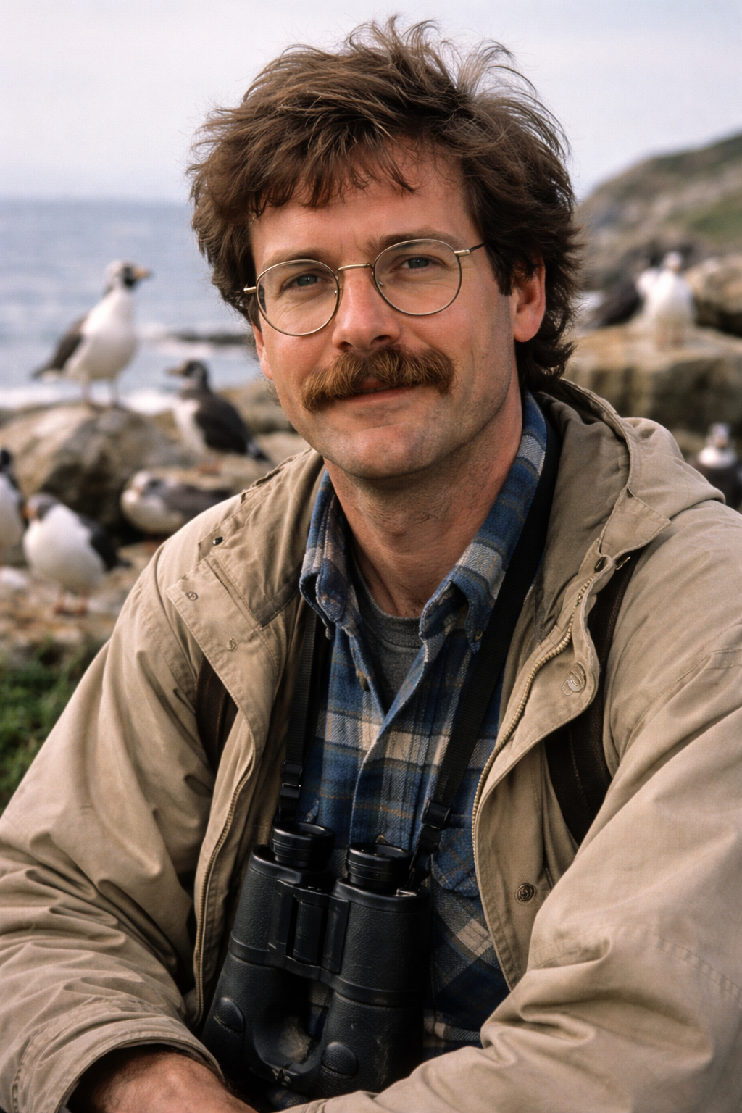
Missing Person Information
Name: Dr. Barry Raven
Age: 42
Sex: Male
Race: Caucasian
Height: 5'11"
Weight: Approx. 175 lbs
Last Known Sighting: Destination Unknown, last seen on evening of June 12, 1984.
Distinguishing Features: Seen often with binoculars. Typically has a mustache. Wears circular wire-frame eyeglasses.Reporting Party
Name: Hazel Donne
Relationship to Missing Person: Acquaintance / Friend
Contact Information: Recorded with Rural Police DepartmentCircumstances of Disappearance
On June 16, 1984, reporting party Hazel Donne contacted the Rural Police Department to report that Dr. Barry Raven had not been seen or heard from since the evening of June 12, 1984.
Mrs. Donne stated that she, Dr. Raven, her husband Billy Donne, and mutual acquaintance Patricia “Patty” Stone had arranged to meet to celebrate daughter Stacy Donne’s 15th birthday dinner on the evening of June 15, 1984. According to Mrs. Donne, the group planned to share a meal together and watch a televised sporting event or play a game afterward.
Mrs. Donne reported that Dr. Raven did not arrive at the scheduled time and failed to respond to repeated telephone calls placed after his absence from the gathering.
Concerned for his wellbeing, Mrs. Donne stated she went to Dr. Raven’s residence on the afternoon of June 16, 1984 for a welfare check. She reported receiving no answer at the door and observed no visible signs of activity inside the home.
Following this, Mrs. Donne contacted law enforcement to request a formal welfare check and to formally file a missing person report.Additional Notes
Preliminary interviews with Billy Donne and Patricia Stone have been scheduled to verify the details of the planned meeting and to establish Dr. Raven’s last known movements prior to disappearance.
At the time of this report, there are no confirmed signs of forced entry or disturbance at the residence. Given Dr. Raven’s professional standing in the community, the case has drawn increased local attention.
Investigation remains active.Status: Active Investigation
Filed via: Manual Records System
Case Priority: Standard Missing Person Protocol
Filed by:
Captain Edward Haskins
Rural Police Department
Kotzebue, Alaska

