RURAL KOTZEBUE POLICE

MARINE INCIDENT REPORT
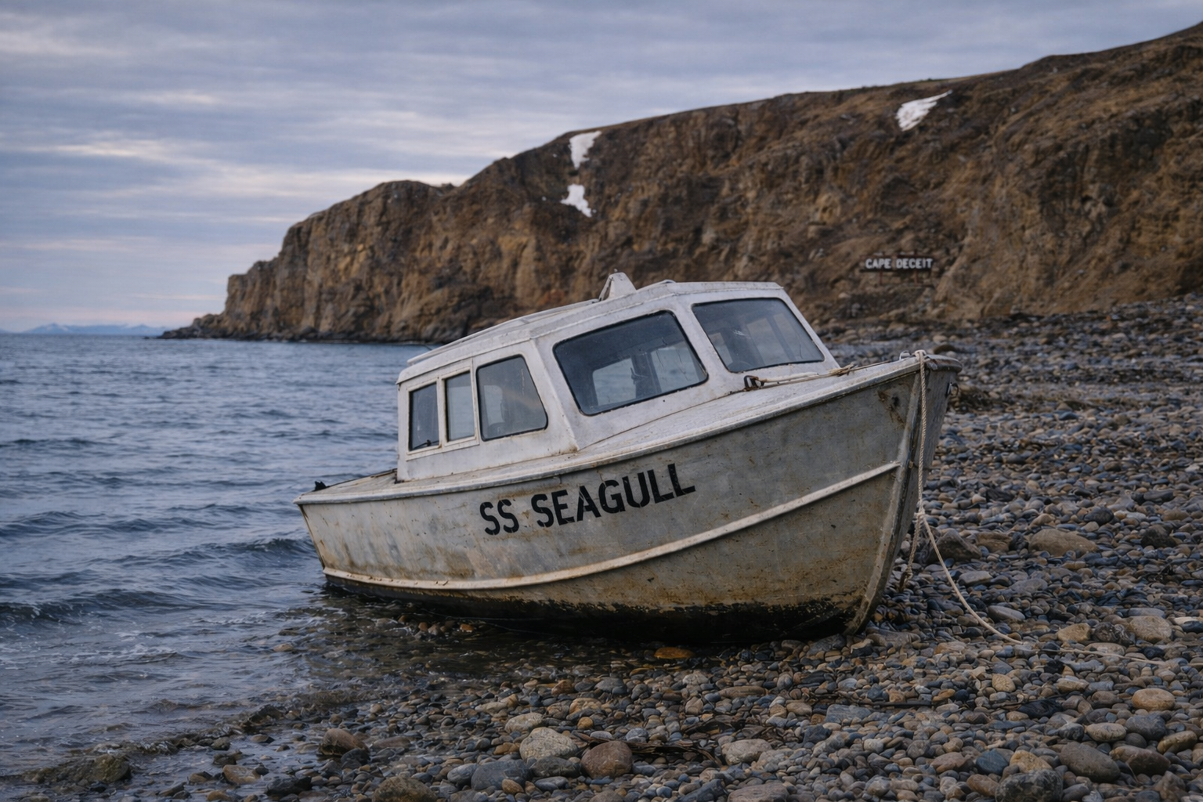
Case Number: RKP-AST-26-0812-903
Date: August 12, 1984
Reporting Officer: Sgt. Elaine Mercer (RP, Kotzebue Detachment)
Incident Type: Abandoned Vessel / Welfare & Status Check
Location: Cape Deceit, Alaska

INITIAL REPORT SUMMARY
On August 12, 1984, the Rural Kotzebue Police Department received a tip from local boaters operating along the Cape Deceit coastline reporting the presence of an unresponsive and seemingly abandoned vessel grounded offshore.
The vessel was later identified as the S.S. Seagull.
According to the reporting parties, the ship appeared to have been in place for “quite some time,” based on visible deterioration, ice scarring along the hull, and lack of any observable crew activity or signal presence.

DISPATCH RESPONSE
At approximately 09:40 hours, Rural Kotzebue Police coordinated a marine patrol response with local assistance due to weather conditions and shallow coastal terrain.
Upon approach, responding units confirmed visual contact with the vessel approximately 1.8 nautical miles off Cape Deceit. The ship appeared grounded and immobile in shallow waters near the shoreline.
No distress signals, flares, or radio transmissions were detected during approach.

ON-SCENE OBSERVATIONS
- Vessel Name: S.S. Seagull (confirmed via hull marking)
- Condition: Stationary, partially grounded
- Exterior: Heavy weathering consistent with extended exposure; salt and ice accumulation present
- Deck: No visible personnel observed
- Audio/Signal: No active radio response received
- Environmental: Dense fog intermittently reducing visibility; strong coastal winds reported
Initial visual sweep suggests the vessel has not been actively operated in recent days. Duration of abandonment is currently undetermined but estimated to exceed several days to weeks based on preliminary assessment.

WITNESS STATEMENT (SUMMARY – LOCAL BOATERS)
Reporting individuals stated they had passed the area multiple times over the past week and “noticed it was there for quite some time,” but initially assumed it was either anchored for weather delay or engaged in local operations.
Concern was raised only after repeated sightings without any observed movement, signaling, or crew activity.

ACTION TAKEN
- Vessel status logged into state marine incident registry
- Search perimeter established along Cape Deceit shoreline
- Coordination initiated with Coast Guard for aerial reconnaissance (weather permitting)
- Boarding operation pending due to surf conditions and grounding stability concerns
- Attempted radio contact with vessel: No response

PRELIMINARY ASSESSMENT
At this time, the S.S. Seagull is classified as an unresponsive vessel of unknown status. Possible explanations include mechanical failure, evacuation prior to grounding, or extended abandonment prior to drift/strand.
No confirmed evidence of crew presence has been observed. Investigation remains active.

