RURAL KOTZEBUE POLICE
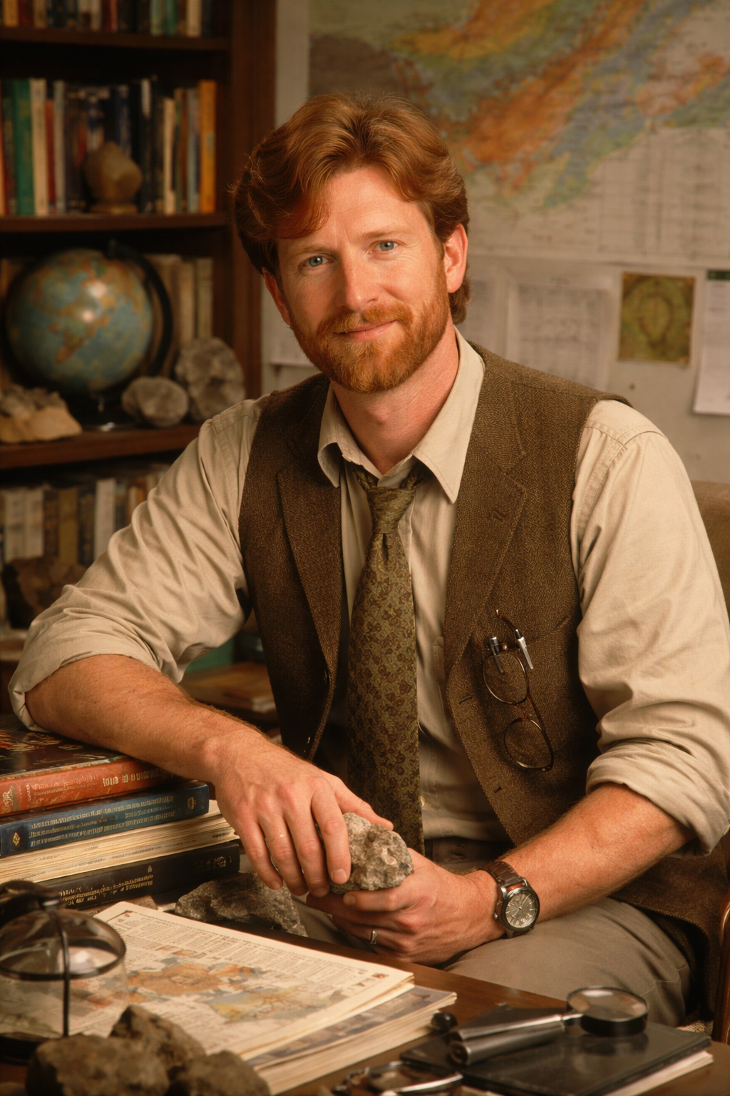

INTERVIEW TRANSCRIPT
Case Number: RKP-KO-84-0618-447
Date: June 18, 1984
Time: 10:22 AM
Officer: Sgt. Elaine Mercer
Subject: Dr. Henry Council
Related Case: Missing Person – Dr. Barry RavenBEGIN TRANSCRIPT
Sgt. Mercer: State your full name for the record.
Henry Council: Dr. Henry Council.
Sgt. Mercer: Thank you for coming in. We understand you just arrived in Kotzebue this morning?
Henry Council: Yes. I wasn’t in town before now.
Sgt. Mercer: Understood. You look like you’ve had some rough travel.
Henry Council: Oh, yeah. I traveled all the way from far away—Anchorage, then a delayed layover—and I’ve basically been sleeping on an airport floor since yesterday. That never agrees with me.
Sgt. Mercer: Looks like it was a dirty floor.
Henry Council: It absolutely was.
Sgt. Mercer: We need to discuss Dr. Barry Raven. He has been missing since the evening of June 15th. When was the last time you had contact with him?
Henry Council: Before I left. Briefly. We were coordinating field plans, but nothing formal that week.
Sgt. Mercer: What were those plans?
Henry Council: Coastal survey work. Our working route was intended to begin near Sheshalik.
Sgt. Mercer: Sheshalik, Alaska?
Henry Council: Yes. From there, the plan was to move north along Cape Krusenstern.
Sgt. Mercer: And Dr. Raven was aware of this route?
Henry Council: Yes. That was the shared plan for the season’s fieldwork.
Sgt. Mercer: Was he expected to travel alone at any point?
Henry Council: No. He shouldn’t have gone by himself. That wasn’t the arrangement.
Sgt. Mercer: Do you know if he departed from that plan?
Henry Council: I don’t have confirmation. But if he did, it would have been outside what we agreed upon.
Sgt. Mercer: When did you last speak with him directly?
Henry Council: Early May. Everything was still normal at that point.
Sgt. Mercer: Did he indicate any change in schedule or personal travel plans?
Henry Council: No.
Sgt. Mercer: Are you aware of any reason he would deviate from the agreed field route without informing you?
Henry Council: Not professionally. Personally, I can’t speak to that.
Sgt. Mercer: We’ve received reports from other individuals suggesting uncertainty regarding his movements starting on the night of the 15th.
Henry Council: That doesn’t surprise me, given how loosely people tend to track field schedules up here.
Sgt. Mercer: You are saying communication breakdown is common?
Henry Council: In remote work, yes. But Barry was usually more careful than that.
Sgt. Mercer: Do you believe he is still in the Cape Krusenstern region?
Henry Council: If he followed the plan, yes. Sheshalik northward along the coast.
Sgt. Mercer: We will be organizing search operations based on that information.
Henry Council: That’s the correct area to start with.END TRANSCRIPT
Officer Notes (Sgt. Mercer):
Subject recently arrived from Anchorage; confirms fatigue and extended travel delay. Provides first structured field route for Dr. Raven (Sheshalik → Cape Krusenstern northward). States Raven should not have been alone, suggesting deviation from planned expedition. Search parameters now geographically narrowed. Coordination with field teams advised immediately.

